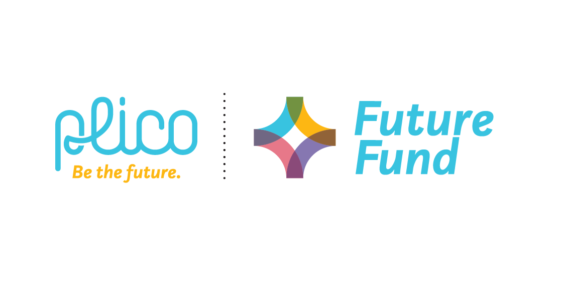

Plico Future Fund – Application Form
- Applicant information
Organisation Name
ABN (if applicable)
Contact Person
Position/Role
Email
Phone
Address
Is your organisation/group incorporated? Yes/No

- Project information
Project title
Funding requested

- Grant category (please select one)
☐ Conservation Grant (up to $10,000)
☐ Sustainability Grant (up to $10,000)
☐ Innovation Grant (up to $20,000)

- Project Description
Please include your project details below. Keep responses to a limit of 50 words. You can include supporting materials as attachments with this application form.
Project summary
Expected start and finish dates
Location
Objectives
Project benefits / expected outcomes
Planned activities – what will the funding be used for?
How will you measure success?

How will you engage the community?
What partnerships have/will be established?

What additional funding will support the project?
How will the project be sustained into the future (if relevant)?
What experience does your organisation have in managing similar projects?
Do you have all the necessary approvals for your project to proceed? If not, what approvals are required?
How will you promote Plico’s funding support? Please list all opportunities ie Media Release, 3 x social media posts, email to database etc
Does your organisation or funding beneficiaries have a connection with Plico? If so, please provide details.

- Budget and Funding request
Please complete the budget breakdown for your entire project below. Include relevant quotations and costings as supporting material with your application.

Budget Items (what the money will be spent on) | This Grant  ($ inc GST | Other Funding Amount  ($ inc GST) | In-Kind Support (Estimate the $ value of in-kind support) | Source & Status of other funding
Example: Solar panels and battery | $5000 | $4000  $1000 | $500 | $1000 from applicant - fundraising (pending)  $4000 from City of Albatros (confirmed)
TOTAL

TOTAL PROJECT COST (including in-kind contributions) =

- Declaration
I, the undersigned, certify that I have read and understood the Plico Future Fund Guidelines, that I have been authorised to submit this application and that the information contained herein and attached is, to the best of my knowledge, true and correct.

Name:
Position:
Signed:
Date:

Please submit this application and supporting materials via email to: pcc@plicoenergy.com.au

